Pairs Trading Simulation Running With No Code Adjustments:

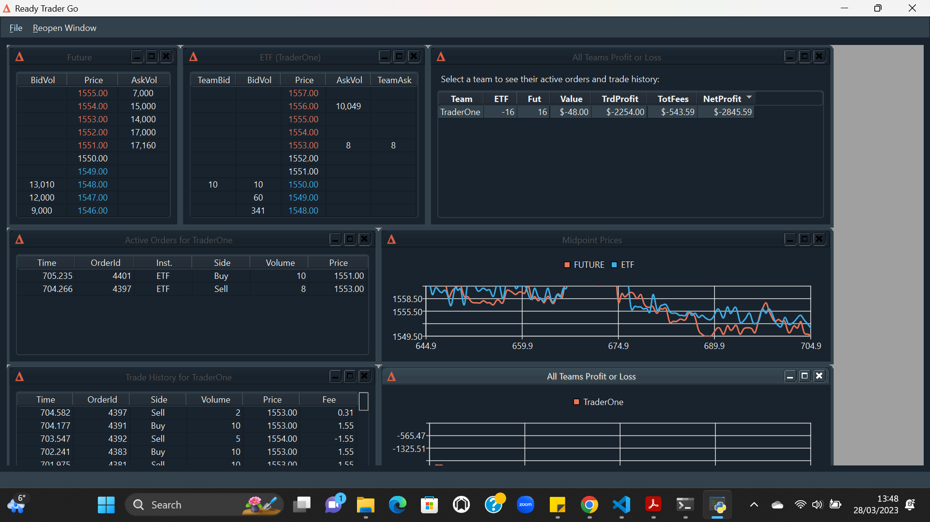Pairs Trading Simulation Running With No Code Adjustments After Execution:

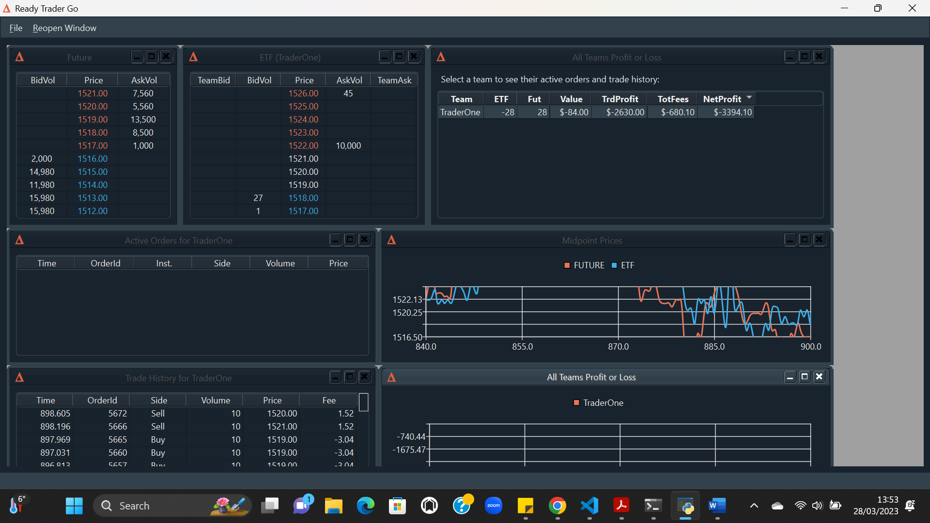

Pairs Trading Simulation Running With Code Adjustments:

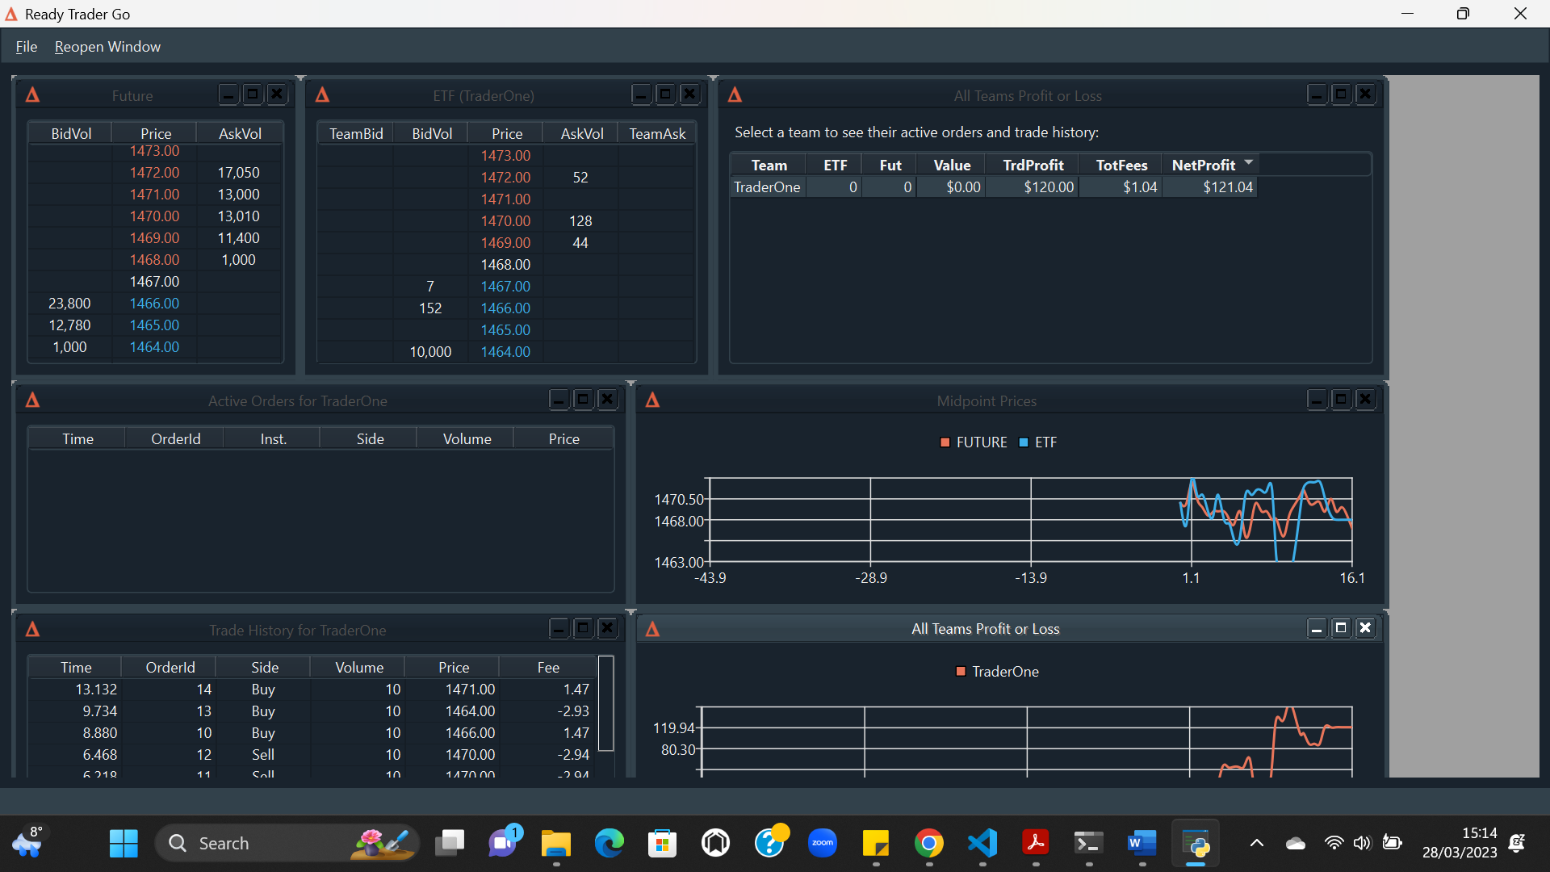

Pairs Trading Simulation Running With Code Adjustments After Execution:

